Room E

EQ1 Cholecystectomy Complications
Stem: You are called to the ER to see a 65-year-old man who presents with worsening epigastric and RUQ abdominal pian, 3 days after laparoscopic cholecystectomy for acute, calculous cholecystitis.
Reports, PO intolerance, chills, fevers, jaundice, darkened urine.
He is otherwise without significant past medical or surgical history.
Vitals : HR 114bpm, BP 94/37; 94% on RA, 38.8C
PE: Ill appearing, lethargic, jaundice, scleral icterus Mildly distended, TTP in the RUQ and epigastrium.
labs: WBC 16.4k; Tbili 4.3; AST 143; ALT157; ALK Phos 312; Creatinine 1.73 (normal 0.90)

Stem: You are called to the ED to see a 78 yo man who presents with 3 day history of fevers and chills, sweats and feeling poorly. He reports RUQ abdominal pain and some nausea but no emesis. He is otherwise healthy.
Vitals: T=99.9 degrees, BP=100/60, HR 110, and RR of 20.
Physical exam : Tender to palpation in the right upper quadrant without guarding or peritoneal signs.
Labs: WBC of 18K, LFTs slightly elevated, otherwise rest of labs normal.
PMH/PSH: Diverticulitis. Colonoscopy 1 year ago with diverticulosis

What’s the initial study would you like to order now?
RUQ US –dilated intra and extrahepatic bile ducts with CBD measuring 1.1cm, mild RUQ fluid, and distal common bile duct stone.

How are you going to manage this patient.
- Sepsis workup.
- Resuscitation / hydration/ antibiotics.
- ERCP : You are not credentialed to do it and your GI colleague is on vacation.
- PTC: Your IR colleagues are not available
- Urgent CBD exploration:
  - Open CBD Exploration.
  - Kocherize the duodenum, palpation of the common bile duct to assess location/mobility of the stone, exposure of anterior CBD
  - Place sutures at the 10 and 2 positions and make an anterior vertical ductotomy.
  - Flush duct with small diameter red rubber and pass a biliary Fogarty catheter proximally and distally until all stones are removed.
  - Choledochoscope can be used with wire basket to retrieve challenging stones.
  - Close ductotomy over a 14 fr T-tube
  - Perform completion cholangiogram.
  - Leave JP drain.

Scenario 2: Same patient arrives, RUQ US notes intra and extra hepatic ductal dilation, mild fluid, no stone is appreciated. You are now in a tertiary center with all images and expertise available.
- ERCP or MRCP or advanced imaging to delineate etiology → 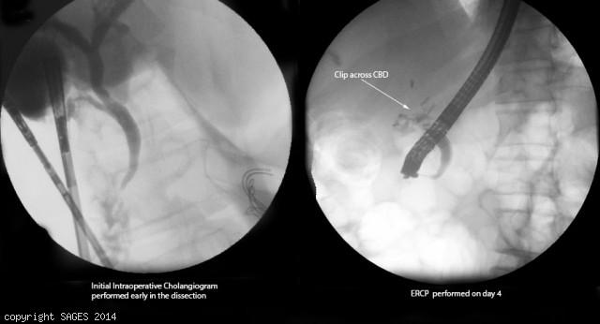
Concern for clip across CBD
- Antibiotics
- IR consultation for PTC.
You take the patient to the OR for repair, how do you repair the following?
- Injury < 50% circumference, not caused by cautery - Repair over T tube.
- Transection < 1 cm in size and away from bifurcation - End to end anastomosis.
- More severe injury, or close to the bifurcation: Hepaticojejunostomy -- Describe.
  - Identify CBD
  - Place two traction sutures on either side of the dilated bile duct.
  - The distal CBD is ligated.
  - The duct is divided below the traction sutures.
  - The end of the common duct is then trimmed to achieve maximal diameter.
  - fashion a Roux-en-Y jejunal limb
  - This limb is identified and transected with a stapling device 30-35 cm from the ligament of Treitz.
  - A single-layer anastomosis can be performed by a side-to-side anastomosis to the Roux limb
Scenario 3: Same patient however with AST/ALT and Alk phos within normal limits, Tbili slightly elevated to 2.4. RUQ US shows concern for large fluid collection in the RUQ.
1. HIDA: Shows biliary leak.
2. ERCP obtained → cystic duct stump leak confirmed → Sphincterotomy and Stent
3. IR for drainage of RUQ fluid collection if symptoms do not resolve, persistent leakage or septic.

EQ2 Perforated Appendicitis
Stem: You see a 45y male in the ER complaining of 5 days of abdominal pain. Pain was initially periumbilical but now is diffuse. For the past 3 days, he has had nausea, vomiting, and fevers. He presents now as he could no longer tolerate oral intake.
Vital signs: Bl. Pr 139/97, HR 118, Temp 39.2°C, RR 19.
Abdomen is nondistended and he has tenderness to palpation in the RLQ with focal rebound tenderness and voluntary guarding.
No PMH or PSH
WBC 18000, Creatinine 1.8

What is your differential diagnosis (Resident should recognize delayed presentation)
- Perforated appendicitis
- IBD related enterocolitis
- Perforated Meckle’s
- Right sided diverticulitis
- Perforated malignancy

What would you like to do?
- CT A/P
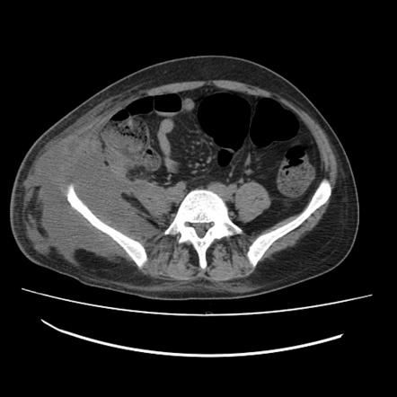

- Fluid bolus, hydration
- Blood cultures, UA
- Broad spectrum Abx.

How are you going to manage this patient?

- Admission
- Continue resuscitation / hydration/ antibiotics.
- IR drainage
(Treatment depends on the extent of the inflammatory process. Though patients with evidence of perforated appendicitis without a large abscess may benefit from appendectomy at the time of presentation. Howeverthis patient has evidence of a large amount of inflammation and free fluid in the RLQ, immediate surgical intervention may do more harm than good. In this setting, appendectomy is associated with a significantly higher rate of complications)

Scenario continues:
Patient gets IR drain next day, WBC improves the day after so as the rest of the labs, pain improves and you advance patient diet, bowel function returns and patient is discharged home, he comes to see you in the clinic and you remove the drain. He comes to see you, now 6 weeks later.
Describes some residual discomfort but not like how it was, you obtain new CT, no residual abscess, now what?

- Plan for a colonoscopy, Describe….
  - Resident should plan to do the colonoscopy themselves, remember to bowel prep the patient and describe steps.

Scenario Continues:
You perform the colonoscopy and apart from 4 mm adenomatous polyp at the sigmoid colon, coloscopy was normal to the cecum, appendiceal orifice seen.

Patient still with RLQ discomfort what would you offer?

Interval appendectomy.

Can you list indications for interval appendectomy?
- Recurrent appendicitis
- Persistent RLQ pain
- Fecalith
- Age over 40 years, and symptoms concerning for malignancy

You take the patient to the OR for laparoscopic appendectomy, during the procedure you decide to open due to adhesions, you make an incision to open at McBurney’s point,
Describe how to perform open appendectomy in general

- Skin incision at McBurney’s point or point of maximal tenderness.
- Open external oblique aponeurosis and bluntly separate internal oblique and transverse abdominis muscles.
- Incise peritoneum.
- Identify appendix and deliver into operative field.
- Divide mesoappendix.
- Place purse-string suture around base of appendix.
- Clamp crush base of appendix and ligate and divide appendix at its base.
- Invaginate appendiceal stump into base of cecum.
- Close peritoneum, fascia, and
EQ3 Large Abdominal Aortic Aneurysm
Stem: A 68 year-old-male is worked up by his PCP for lower GI bleeding and found on colonoscopy to have a mass in the sigmoid colon.
Biopsy showed a T3 adenocarcinoma.
For staging, CT of the chest abdomen and pelvis reveals a 2cm sigmoid mass, no evidence of metastatic disease, and a 6.5 cm infrarenal AAA.

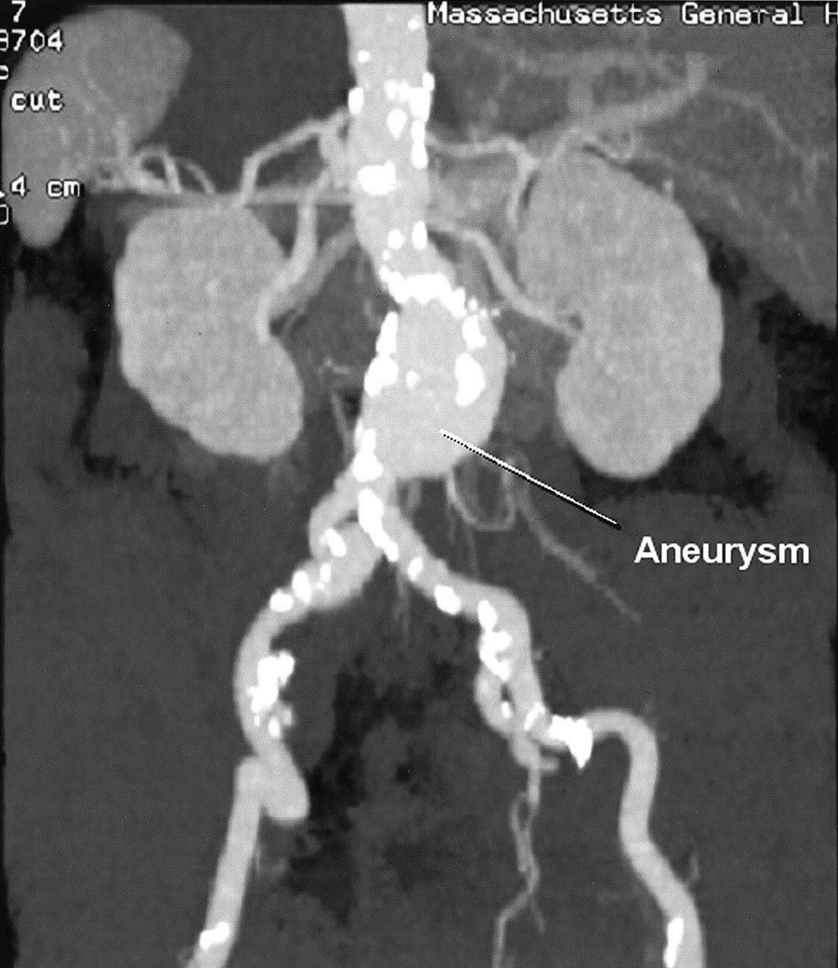
He is referred to your office for management.
PMH: diet-controlled diabetes, and hypertension on lisinopril.
Social Hx: 50 pack-year smoking.
He is vitally normal
Labs : Hb 7.2.

Any Additional Workup or Studies?

- CTA to evaluate AAA anatomy:
Shows 1.7cm infrarenal neck, 2cm neck diameter, 40° neck angle, 1cm femoral artery diameter.

What Would you like to do Now?
- EVAR candidate
- Pre-op optimization
  - Smoking cessation
  - Diabetes and BP control.
  - Monitor anemia optimize with iron and vitamin supplements.
  - Pre-op type and screen
- EVAR first, followed by left hemicolectomy in 2 weeks.

What is the risk of aneurysm rupture after laparotomy for non-vascular cause?

Increased may be due to activation of matrix metalloproteinases. Thus, aneurysm should be addressed.

Scenario continues: The patient is taken to the OR for EVAR, and on post op CT scan 1 week later demonstrates an asymptomatic type 2 endoleak from the IMA. How would you like to proceed, keeping in mind his sigmoid cancer history?
- Proceed with colectomy
- High ligation of the IMA which will resolve the endoleak.

Scenario: A similar patient presents to the ED with abdominal pain and is found to have an obstructing sigmoid mass and a concurrent 5.5 cm AAA. How would you proceed in this case?
- Urgent colectomy for resection of the mass and relief of the obstruction. Strongly consider colostomy or diverting loop ileostomy
- Interval AAA repair either open retroperitoneal or EVAR approach

This patient will need adjuvant chemotherapy, when should he get it?
After AAA repair to minimize risk of AAA rupture

Scenario: The same patient, with an obstructing sigmoid mass but now an 8cm AAA.
- Both the obstruction and the AAA should be dealt with urgently.
- Consider stenting the obstruction as a bridge to colectomy
- AAA repair during this hospitalization
- CT chest abdomen and pelvis during this hospitalization for metastatic workup for colon cancer

